

**Activity based**

**Project Report on**

**Computer Networks**

**Submitted to Vishwakarma University, Pune**

**Under the Initiative of**

**Contemporary Curriculum, Pedagogy, and Practice (C2P2)**

**By**

**Merwin Pinto**

**SRN No : 202100102**

**Roll No : 01**

**Diya Oswal**

**SRN No : 202101718**

**Roll No : 41**

**Div : E**

**Third Year Engineering**

**Department of Computer Engineering**

**Faculty of Science and Technology**

**Academic Year**

**2023-2024**

**Project Description:**

Parity Bit Checker for Error detection and Correction:

The parity bit checker is a network method designed to detect errors and check the integrity of the data received at the receiver side by the sender side. The parity check method adds a bit to the original data for checking errors at the receiver end.

There are mainly two types of Parity that is **Even Parity and Odd Parity**

**This Parity Checker is further divided into 3 parts**

1. Message representation into Binary bits and frames
2. Parity bit checking using Even and odd parity concepts
3. comparing performances with other error detection Techniques

**PROJECT MODULE 3 :** Comparing performances with other error detection Techniques

**Performance Analysis:**

Parity bit checking is a simple and efficient error detection technique that involves adding an extra bit to the data transmission. The parity bit is calculated based on the number of 1s in the data, and it is set to either 0 or 1 to make the total number of 1s even (even parity) or odd (odd parity). When the data is received, the parity bit is recalculated and compared to the original parity bit. If the two parity bits are the same, then the data is considered correct. If the two parity bits are different, then an error has occurred.

Parity bit checking is a very simple and efficient way to detect single-bit errors. However, it is important to note that it cannot detect all types of errors, such as two-bit errors or errors that occur in the parity bit itself. For more sophisticated error detection and correction techniques, such as Hamming codes, are used.

**Advantages of Parity Bit Checking**

Simple and efficient to implement

Low computational overhead

Can detect single-bit errors

Does not require complex hardware or software

**Disadvantages of Parity Bit Checking**

Cannot detect all types of errors, such as two-bit errors or errors in the parity bit itself

Not as reliable as more sophisticated error detection techniques

Can add overhead to data transmissions

**Different Error Detection Techniques**

**Hamming Distance**

Hamming distance between two strings of equal length is the number of positions at which the corresponding symbols are different. In other words, it measures the minimum number of substitutions required to change one string into the other. The Hamming distance between two strings, a and b, is denoted as d(a, b).

Applications

The Hamming distance is used in a variety of applications, including:

**Error detection and correction**: The Hamming distance can be used to detect and correct errors in data transmissions. For example, if the Hamming distance between two codewords is 1, then we can be sure that there is only one error in the data. If the Hamming distance is 2, then we can correct the error by flipping the bit that is different in the two codewords.

**Data compression**: The Hamming distance can be used to compress data by removing redundant information. For example, we can use the Hamming distance to identify and remove duplicate codewords in a dictionary.

**Cryptography**: The Hamming distance can be used to measure the similarity of two cryptographic keys. A small Hamming distance between two keys suggests that they may be related, which could be a security vulnerability.

Properties

The Hamming distance has several properties that make it a useful metric for measuring the similarity of strings:

**Non-negativity**: The Hamming distance between any two strings is always non-negative.

**Symmetry**: The Hamming distance between two strings is equal to the Hamming distance between the reversed strings.

Identity: The Hamming distance between two identical strings is zero.

**Triangle inequality**: For any three strings, a, b, and c, the Hamming distance between a and c is less than or equal to the sum of the Hamming distances between a and b and b and c.

**Comparison**



**Analysis Parameters**

To effectively compare parity bit checking with other error detection techniques, several performance parameters need to be considered:

**Error Detection Capability**: The ability to detect different types of errors, such as single-bit errors, multi-bit errors, and burst errors.

**Error Detection Efficiency**: The ratio of errors detected to the number of redundant bits used.

**Implementation Complexity**: The complexity of the hardware or software required to implement the error detection technique.

**Computational Overhead**: The additional processing time required to perform error detection.

**Error Correction Capability**: The ability to not only detect errors but also correct them without retransmission.

**Cyclic Redundancy Check (CRC)**

Cyclic Redundancy Check (CRC) is an error-detecting code commonly used in digital networks and storage devices to detect accidental changes to digital data. Blocks of data entering these systems get a short check value attached, based on the remainder of a polynomial division of their contents. On retrieval, the calculation is repeated and, in the event the check values do not match, corrective action can be taken against data corruption. CRCs can be used for error correction (see bitfilters).

**How it Works**

A CRC-enabled device calculates a short, fixed-length binary sequence, known as the check value or CRC, for each block of data to be sent or stored and appends it to the data, forming a codeword. When a codeword is received or read, the device either compares its check value with one freshly calculated from the data block, or equivalently, performs a CRC on the whole codeword and compares the resulting check value with an expected residue constant.

**CRC Calculation**

The CRC calculation is based on polynomial division. The data block is divided by a predetermined generator polynomial, and the remainder is the CRC value. The generator polynomial is a carefully chosen binary polynomial that has certain properties that make it suitable for CRC calculations.

**CRC Properties**

CRCs have several properties that make them effective error detection codes:

They are easy to calculate and implement in hardware or software.

They can detect a wide range of errors, including single-bit errors, multi-bit errors, and burst errors.

They are relatively immune to noise

.

**CRC Applications**

CRCs are used in a wide variety of applications, including:

**Data communication protocols**: CRCs are used in many data communication protocols, such as Ethernet, PPP, and USB, to detect errors in data transmissions.

**Storage devices**: CRCs are used in storage devices, such as hard disks and solid-state drives, to detect errors in stored data.

**Error correction codes**: CRCs can be used in conjunction with other error detection and correction codes to provide more sophisticated error protection.

**Implementation :**

**Code :**

import socket

import tkinter as tk

from tkinter import scrolledtext

from code_file import Frame_creation, check_parity, simulate_frame_corruption

class MultiGUI:

    def __init__(self, master):

*self*.master = master

        master.title("Sender's GUI")

*self*.prompt_label = tk.Label(master, text="Type your message:")

*self*.prompt_label.pack(pady=5)

*self*.input_entry = tk.Entry(master, width=40)

*self*.input_entry.pack(padx=10, pady=10)

*self*.connect_button = tk.Button(master, text="Connect", command=*self*.connect_to_server)

*self*.connect_button.pack(pady=10)

*self*.prompt_label1 = tk.Label(master, text=f"Message converted to bit frames ")

*self*.prompt_label1.pack(pady=5)

*self*.text_area1 = scrolledtext.ScrolledText(master, wrap=tk.WORD, width=40, height=10)

*self*.text_area1.pack(padx=10, pady=10)

*self*.prompt_label2 = tk.Label(master, text="Message Sent")

*self*.prompt_label2.pack(pady=5)

*self*.text_area2 = scrolledtext.ScrolledText(master, wrap=tk.WORD, width=40, height=2)

*self*.text_area2.pack(padx=10, pady=10)

*self*.prompt_label3 = tk.Label(master, text="Frames Sent")

*self*.prompt_label3.pack(pady=5)

*self*.text_area3 = scrolledtext.ScrolledText(master, wrap=tk.WORD, width=40, height=10)

*self*.text_area3.pack(padx=10, pady=10)

*self*.prompt_label4 = tk.Label(master, text="Frame Parity")

*self*.prompt_label4.pack(pady=5)

*self*.text_area4 = scrolledtext.ScrolledText(master, wrap=tk.WORD, width=40, height=10)

*self*.text_area4.pack(padx=10, pady=10)

*self*.prompt_label5 = tk.Label(master, text="Received Frames")

*self*.prompt_label5.pack(pady=5)

*self*.text_area5 = scrolledtext.ScrolledText(master, wrap=tk.WORD, width=40, height=10)

*self*.text_area5.pack(padx=10, pady=10)

*self*.prompt_label6 = tk.Label(master, text="Received Parity")

*self*.prompt_label6.pack(pady=5)

*self*.text_area6 = scrolledtext.ScrolledText(master, wrap=tk.WORD, width=40, height=10)

*self*.text_area6.pack(padx=10, pady=10)

*self*.text_area_msg = scrolledtext.ScrolledText(master, wrap=tk.WORD, width=40, height=10)

*self*.text_area_msg.pack(padx=10, pady=10)

    def read_file(self, file_name):

        try:

            with open(file_name, 'r') as file:

                content = file.read()

            return content

        except FileNotFoundError:

            return None

    def connect_to_server(self):

        string = *self*.input_entry.get()

        frame_size = 32

        char_bit = 4

        error_rate = 1

        skip_probability = 0.5

        client_socket = socket.socket(socket.AF_INET, socket.SOCK_STREAM)

        port_no = ('localhost', 8080)

        client_socket.connect(port_no)

        frames = Frame_creation(string, frame_size, char_bit)

*self*.text_area1.insert(tk.END, f"\nFrames divided into {frame_size} bit frames \n{frames}\n")

        parity_type_holder1 = []

*self*.text_area2.insert(tk.END, f"\nMessage sent > > {string}\n")

        for fr in frames:

            frame_type = check_parity(fr)

            parity_type_holder1.append(frame_type)

        for frame, parity in zip(frames, parity_type_holder1):

            client_socket.send(frame.encode())

*self*.text_area3.insert(tk.END, f"\nSent frames: {frame}\n")

*self*.text_area4.insert(tk.END, f"\nParity of frames: {parity}\n")

        with open("p1.txt", 'w') as file:

            for i in parity_type_holder1:

                file.write(i + '\n')

        content1 = *self*.read_file("p1.txt")

        C_received_frames = simulate_frame_corruption(frames, error_rate, skip_probability)

        parity_type_holder2 = []

        for fr2 in C_received_frames:

            client_socket.send(frame.encode())

            frame_type2 = check_parity(fr2)

            parity_type_holder2.append(frame_type)

        for frame, parity in zip(C_received_frames, parity_type_holder2):

            client_socket.send(frame.encode())

*self*.text_area5.insert(tk.END, f"\nReceived frames: {frame}\n")

*self*.text_area6.insert(tk.END, f"\nParity of frames: {parity}\n")

        with open("p2.txt", 'w') as file:

            for i in parity_type_holder2:

                file.write(i + '\n')

        client_socket.close()

*self*.create_receiver_window(C_received_frames, parity_type_holder2)

    def create_receiver_window(self, received_frames, parity_types):

            receiver_window = tk.Toplevel(*self*.master)

            receiver_window.title("Receiver's GUI")

            prompt_label_received_frames1 = tk.Label(receiver_window, text="Received Frames")

            prompt_label_received_frames1.pack(pady=5)

            text_area_received_frames1 = scrolledtext.ScrolledText(receiver_window, wrap=tk.WORD, width=40, height=10)

            text_area_received_frames1.pack(padx=10, pady=10)

            prompt_label_received_parity2 = tk.Label(receiver_window, text="Received Parity")

            prompt_label_received_parity2.pack(pady=5)

            text_area_received_parity2 = scrolledtext.ScrolledText(receiver_window, wrap=tk.WORD, width=40, height=10)

            text_area_received_parity2.pack(padx=10, pady=10)

            for frame, parity in zip(received_frames, parity_types):

                text_area_received_frames1.insert(tk.END, f"\nReceived frame: {frame}\n")

                text_area_received_parity2.insert(tk.END, f"\nReceived parity: {parity}\n")

            content1 = *self*.read_file("p1.txt")

            content2 = *self*.read_file("p2.txt")

            if content1 == content2:

                result_message = "Message Received successfully"

            else:

                result_message = "Message Corrupted, please retransmit"

*# Display the result in the receiver's GUI*

            result_label = tk.Label(receiver_window, text=f"Message accuracy: {result_message}")

            result_label.pack(pady=10)

*self*.text_area_msg.insert(tk.END, f"\nMessage accuracy: {result_message}\n")

if __name__ == "__main__":

    root = tk.Tk()

    app = MultiGUI(root)

    root.mainloop()

**Output:**

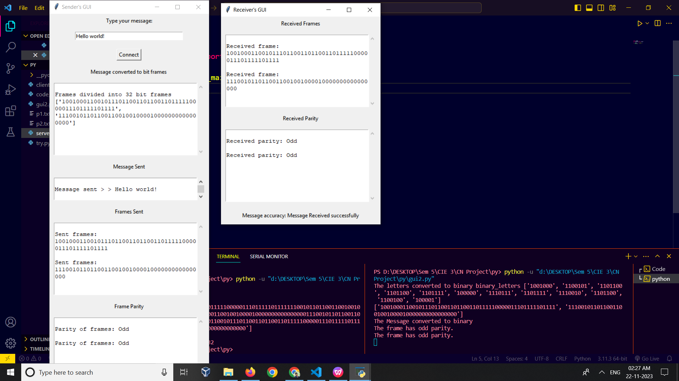

**Conclusion :**

The final analysis of various detection methods provides us a comprehensive overview of Parity checker , Hamming distance and Cyclic Redundancy Check (CRC) as error detection techniques.helps us understand the concepts of Parity checker, Hamming distance, its applications, properties, and comparison with other error detection techniques. Additionally, helps us understand and explore CRC, its working principle, properties, and applications.